APPROVED
by Order of Federal Environmental, Industrial and Nuclear Supervision Service No. 84 of March 22, 2022

Safety Guide in the Use of Atomic Energy
“Dynamic Monitoring of Civil Structures of Nuclear Facilities”
(RB-045-22)
I. General
1. The Safety Guide in the use of atomic energy “Dynamic Monitoring of Civil Structures of Nuclear Facilities” (RB-045-22) (hereinafter referred to as the Safety Guide) has been developed in accordance with Article 6 of the Federal Law of November 21, 1995 No. 170-FZ “On the Use of Atomic Energy” in order to facilitate compliance with the requirements of paragraph 5.2 of the federal rules and regulations in the field of the use of atomic energy “Accounting for External Effects of Natural and Man-made Origin on Nuclear Facilities” (NP-064-17) approved by order of Federal Environmental, Industrial and Nuclear Supervision Service of November 30, 2017 No. 514 (registered by the Ministry of Justice of the Russian Federation on December 26, 2017, registration No. 49461).
2. This Safety Guide contains recommendations of Federal Environmental, Industrial and Nuclear Supervision Service on the organization, goals, and monitoring of dynamic characteristics of civil structures of buildings and constructions of nuclear facilities using non-destructive seismoacoustic methods (microseism).
3. This Safety Guide applies to activities in the field of the use of atomic energy related to commissioning, operation and extension of the designated service life of nuclear facilities. At the stage of commissioning of nuclear facilities, dynamic monitoring should be performed at newly constructed nuclear facilities since in this case the initial data needed for comparison and obtaining complete information for further dynamic monitoring will be obtained.
4. This Safety Guide is intended for use by organizations operating nuclear facilities, providing services for monitoring and inspection of civil structures of buildings and constructions of nuclear facilities, as well as developing safety analysis materials to obtain a license for siting, construction, operation and decommissioning of nuclear facilities.
5. The civil structures of buildings and constructions of nuclear facilities considered in this Safety Guide should include load-bearing and enclosing reinforced concrete (cast-in-situ, precast, and precast and cast-in-situ), concrete, stone, reinforced masonry, and metal (metal trusses, columns, crossbars) civil structures.
6. The recommendations of this Safety Guide apply to the following stages of work performed to support the calculated and experimental assessment of the strength and durability of buildings and constructions of nuclear facilities:
generation of data based on the results of inspection of civil structures of buildings and constructions;
generation of data based on the results of vibrodynamic and wave tests of civil structures of buildings and constructions;
creation of a calculation model of a building (construction) based on the analysis of design solutions;
adaptation of the calculation model based on the data of vibrodynamic and wave tests;
monitoring of changes (stability) of dynamic characteristics.
7. A list of abbreviations is given in Appendix 1 to this Safety Guide.
II. The structure of dynamic monitoring of buildings and constructions of nuclear facilities
8. Dynamic monitoring of NF B&C should be carried out in order to:
monitor changes in the determining dynamic parameters over time to predict the strength and stability of the NF B&C CS;
track the degree and speed of changes in the technical condition of the facility and taking, if necessary, urgent measures to prevent an emergency.
9. For dynamic monitoring, the following tasks should be performed:
determine the dynamic characteristics of B&C and individual CS;
assess the state of CS materials by seismoacoustic methods;
monitor changes (stability) of the dynamic characteristics and the state of construction materials over time.
10. Studies of the dynamic characteristics of the safety important CS should be carried out at the stage of NF commissioning and then at least once every 10 years, as well as at each extraordinary inspection of the technical condition of these CS.
11. Dynamic monitoring of NF B&C CS, which are in operational condition, should be carried out once every 10 years. To conduct dynamic monitoring at a specific stage, vibration tests of the CS should be carried out in order to obtain the values of the main dynamic characteristics and compare them with the values obtained at the previous stage.
12. Dynamic monitoring of NF B&C CS, which are in limited operational condition should be carried out during periods determined by the condition of the CS according to the parameters monitored by the stationary systems for automatic monitoring of the condition of the B&S CS. To carry out dynamic monitoring at this stage, integrated activity should be carried out, including vibration tests to obtain the values ​​of the main dynamic characteristics, and surface wave tests and through sonic tests to obtain the strength and resistance values ​​of the bearing and enclosing CS.
13. Dynamic monitoring of B&C and their individual CS should be organized and carried out in several stages:
creation of a primary (initial) database;
development of a dynamic monitoring program;
development of a methodology for determining the dynamic characteristics of the CS;
determination of the dynamic characteristics of the CS to be examined;
assessment of the state of materials of the examined CS;
development of a technical report based on the results of dynamic monitoring, including an analysis of the results of observations and diagnostics of the dynamic parameters of the CS;
development of a technical statement on the results of tests and materials for accounting in the calculation model (if any);
entering the obtained results into the information system for managing the database of dynamic monitoring at each next stage of dynamic monitoring in the form of information presentation, which is identical to the statement.
14. Dynamic monitoring of the technical condition of the NF B&C CS should be carried out in accordance with the dynamic monitoring program developed by a specialized organization in accordance with the terms of reference approved by the management of the examined facility and agreed with the general designer.
15. The procedure, methodology and scope of studies on dynamic monitoring of safety important CS should be set in the dynamic monitoring program.
Recommendations for the structure and content of the dynamic monitoring program are given in Appendix 2 to this Safety Guide.
16. The dynamic characteristics of B&C and individual CS should be determined in order to assess their condition, take them into account in the calculation models and then monitor their changes (stability) over time, while the following dynamic characteristics of the SC should be determined:
natural frequencies (determined by spectra or amplitude-frequency characteristics);
forms of natural fluctuations (frequencies) corresponding to the identified natural frequencies (determined by constructing epures and diagrams of fluctuations at the measurement points);
logarithmic decrement (defined as the ratio of two successive amplitudes of the fluctuating value x in the same direction).
17. The condition of the materials of the examined CS should be examined both for a direct assessment of the rigidity and strength characteristics of the bearing CS, and for their use as additional information in developing and adapting calculation models.
18. For thick-walled CS with one-sided access to their surface (in particular, the CS of “hot” premises of RBMK-1000 reactor units), dynamic monitoring should be performed by the method of surface elastic waves.
19. Based on the results of dynamic monitoring, a technical statement and/or a technical report should be developed and included in the NF B&C data sheet; their recommended form is given in Appendix 3 to this Safety Guide.
20. When performing periodic monitoring, a simplified test pattern should be used when a sensor (sensors) is (are) installed at the point of maximum amplitude of monitored natural fluctuations. The decision on the feasibility and scope of testing by the surface wave method during periodic monitoring should be made on the basis of the results of assessment of the condition of the constructions.
21. For dynamic monitoring, standardized and metrologically certified equipment verified or calibrated in accordance with the procedure established by the legislation of the Russian Federation (the list and technical characteristics of the equipment included in the measuring set is given in Table 1.1 of Appendix 4 to this Safety Guide) should be used.
22. In the course of dynamic monitoring during vibrodynamic tests, the following determining dynamic parameters of natural fluctuations of the CS should be monitored:
natural frequencies (ratio of two generalized characteristics of mass and rigidity);
forms of natural fluctuations;
logarithmic decrement of natural fluctuations;
physical and mechanical properties of the material;
actual geometric dimensions of the sections of the constructions when comparing them with design parameters;
compliance with the actual and calculated static scheme of the structures;
presence of cracks, spalls and destruction;
location, nature and width of crack opening.
23. In the course of dynamic monitoring of changes in the condition of the CS and the building or construction as a whole, monitor should be carried out mainly by their dynamic characteristics (changes in the frequencies of the first vibration frequency and individual higher vibration frequencies).
24. At certain points of the CS, the condition of the construction materials should be monitored using the surface wave method. In this case, the technical statement should include conclusions about the state of the materials of construction at these points in the technical report, and dispersion curves of surface waves obtained during the initial survey, and then at each monitoring stage, are attached.
25. Based on the results of the assessment of the technical condition of the NF B&C CS, criteria for the technical condition of the CS should be assigned. The change in the frequency of the first frequency of free vibrations of the construction should be assigned as the main criterion for dynamic monitoring, while other criteria can also be taken into account (change in the frequency of the second frequency of vibrations, strength and/or effective thickness of the structure).
In accordance with paragraph 6.3 of GOST 31937-2011 “Buildings and construction. Rules for inspection and monitoring of the technical condition” put into effect by order of the Federal Agency for Technical Regulation and Metrology of December 27, 2012 No. 1984-st (hereinafter referred to as GOST 31937-2011), the criterion is to reduce the frequency of the first frequency of free vibrations by 10%. If, according to the results of the initial examination and calculations, the CS are recognized as limited-operating or emergency, this indicator is recommended to be reduced to 5%.
26. Conclusions about the further safe operation of the B&C CS should be made on the basis of a comparison of the obtained data with the results of previous tests, compliance with their reference characteristics or existing databases and estimates of the actual bearing capacity of the constructions in the design model (reference characteristics can be determined in the design model with design technical characteristics of B&C structures).
27. The following operations should be included in the methodology for determining the dynamic characteristics of the CS by their free vibrations excited by an impact impulse load:
excitation and registration of fluctuations using a measuring system, the diagram of which is shown in fig. 2.3 of Appendix 4 to this Safety Guide and then averaging the responses obtained over several actions at each point of application of the load. The number of impact actions at each point of application of the load should be assigned depending on the level of background vibrations (if the background vibration level is lower than 30% of the maximum level during the impact action in the analyzed frequency range, five impacts are sufficient);
if necessary, compiling CS reactions to a combination of impacts;
calculation of Fourier spectra;
analysis of the Fourier spectra in order to highlight the resonant peaks corresponding to various forms of free vibrations;
obtaining, using the inverse Fourier transformation, impulse realizations of the selected resonant peaks for each form of free vibrations;
determination of periods (frequencies) and amplitudes of these fluctuations, as well as their logarithmic decrements;
construction of epures or diagrams of various forms of vibrations.
28. Processing of test results should be performed using specialized software. Processing of the fluctuations (combined realizations) obtained as a result of addition in order to isolate resonant peaks corresponding to the analyzed form of fluctuations should be carried out for each measurement point by adding or subtracting the realizations obtained during impacts at individual points. The methodology for determining the dynamic characteristics is given in Appendix 4 to this Safety Guide.
III. Recommendations for the development (or refinement) of calculation models of civil structures, taking into account the results of their dynamic tests and the assessment of their actual physical and mechanical characteristics
29. Adaptation of calculation models should be carried out by introducing into them the actual physical and mechanical characteristics of structural materials determined using the surface wave method, as well as by comparing the actual dynamic characteristics of the structures with those obtained in the calculation model.
30. Calculation of the strength and stability of the B&C CS under seismic and other design impacts should be carried out taking into account the results of the examination in order to:
identify the reserve (or deficit) of strength and stability of the B&C as a whole and their individual structural elements, taking into account the data on their actual condition obtained as a result of the examination, in accordance with the requirements of the current regulatory documents;
identify the causes that led to the appearance of defects and damage to the civil components and structures found as a result of the examination;
develop proposals based on the analysis of the results of the B&C stability calculation, taking into account the results of the examination as part of engineering and technical measures that must be performed at the facility to restore and maintain its functional stability, under both operational loads and seismic impact of a given intensity, and their design-basis justification (these proposals should be developed on the basis of an analysis of the results of the B&C stability calculation, taking into account the results of the examination).
31. At the stages of development and design of NF B&C, calculations of seismic resistance and resistance to external impacts of natural and man-made origin should be carried out using computer programs that have a certification data sheet issued by Rostechnadzor.
32. The resistance of the B&C CS under external dynamic impacts should be evaluated using the linear-spectral method, the dynamic calculation method and the structural layouts of the B&C (the methods for calculating the resistance of the B&C CS under external impacts are given in Appendix 5 to this Safety Guide). The choice of the calculation method is regulated in NP-031-01 and depends on the form in which the external Impact is specified and on the values of its own dynamic characteristics.
33. Recommendations for the development of a calculation model based on the results of vibration diagnostics of the B&C CS are given in Appendix 6 to this Safety Guide.____________________

APPENDIX 1
to Safety Guide in the use of atomic energy “Dynamic Monitoring of Civil Structures of Nuclear Facilities” approved by Order of Federal Environmental, Industrial and Nuclear Supervision Service No. 84 of March 22, 2022

List of Abbreviations
ADC | – | analogue-digital converter
B&C | – | buildings and constructions
CS | – | civil structures
NF | – | nuclear facility
PC | – | personal computer

_________________

APPENDIX 2
to Safety Guide in the use of atomic energy “Dynamic Monitoring of Civil Structures of Nuclear Facilities” approved by Order of Federal Environmental, Industrial and Nuclear Supervision Service No. 84 of March 22, 2022

Recommendations for the structure and content of the dynamic monitoring program
The following structure and content of the dynamic monitoring program are recommended:
1. Purpose and scope of the program of work;
2. General provisions;
3. Basic regulatory and technical documentation;
4. List of atomic energy facilities, goals and objectives of monitoring;
5. Brief characteristics of monitored facilities;
6. Dynamic test methods, instrumentation, test schemes;
7. Layout of fluctuation sensors;
8. Program for computer processing of fluctuation records;
9. Criteria for evaluating monitoring results;
10. Organization and procedure for dynamic monitoring:
organization of the examination;
procedure for performing examination work;
basic technical requirements for providing access to structures;
11. Requirements for the final documentation;
12. Organizational and technical measures;
13. Safety requirements;
14. Appendix. Plans and sections of the building (construction) with areas and schemes of dynamic monitoring.
The section “List of atomic energy facilities, goals and objectives of monitoring” provides a list of NF CS to be inspected and the results to be achieved during monitoring.
In the section “Brief characteristics of monitored facilities,” the characteristics of the structures subject to monitoring based on the results of the initial examination are given, as well as a table with the results of the initial examination filled in.
The section “Dynamic test methods, instrumentation, test schemes” provides test methods with reference to approved work methods, a list of instruments and equipment used to perform work, indicating verification certificates, as well as test schemes for each method for each structure. With a large amount of work, the test schemes should be transferred to separate annexes.
The section “Criteria for evaluating monitoring results” provides values of changes in the monitored parameters, which require an extraordinary examination of all or some of the monitored structures.
The section "Organization and procedure for dynamic monitoring" indicates the organizations involved in the performance of work, and the organizations that provide and control the work. The procedure for admission of the performers to the facility, the organization of access to the examined structures and the provision of the necessary technical means are described.
The section "Requirements for the final documentation" indicates the regulatory documents that the documentation must comply with, the list and content of the documents issued on the basis of the test results, as well as the requirements for the execution of these documents.
The section "Organizational and technical measures" specifies the activities carried out during the preparation and conduct of work, and indicates those responsible for its implementation.
The section "Safety requirements" specifies the regulatory documents in the field of ensuring the safe conduct of work and those responsible for organizing safety briefings and monitoring during work.

______________

APPENDIX 3
to Safety Guide in the use of atomic energy “Dynamic Monitoring of Civil Structures of Nuclear Facilities” approved by Order of Federal Environmental, Industrial and Nuclear Supervision Service No. 84 of March 22, 2022

Recommended form of technical statement, technical report based on the results of dynamic tests to determine their own dynamic characteristics of civil structures of buildings and constructions

1. The technical statement on dynamic monitoring of the technical condition of the B&C should be drawn up in the form of:
description of the used measuring system;
list of examined CS, methods and actual test schemes for these structures;
test results in the form of epures and/or diagrams of various forms of free fluctuations indicating the frequencies (periods) of these fluctuations, as well as dispersion curves of surface waves (if such tests have been carried out);
analysis of the obtained test results with recommendations for taking them into account when adapting calculation models and dynamic monitoring;
annexes with the test program.
The form of the technical statement is given in Table 1 below.

Table 1
Form of Technical Statement
Statement on dynamic monitoring of technical condition of a building or a construction
1. Facility address and owner
2. Monitoring stage No.
3. Time of monitoring stage
4. Organization that carried out the monitoring stage
5. Previous tilt value of the facility along the major axis
6. Current tilt value of the facility along the major axis
7. Previous tilt value of the facility along the minor axis
8. Current tilt value of the facility along the minor axis
9. Previous value of the period of fundamental frequency of natural fluctuations along the major axis
10. Current value of the period of fundamental frequency of natural fluctuations along the major axis
11. Previous value of the period of fundamental frequency of natural fluctuations along the minor axis
12. Current value of the period of fundamental frequency of natural fluctuations along the minor axis
13. Previous value of the period of fundamental frequency of natural fluctuations along the vertical axis
14. Current value of the period of fundamental frequency of natural fluctuations along the vertical axis
15. Previous value of logarithmic decrement of fundamental frequency of natural fluctuations along the major axis
16. Current value of logarithmic decrement of fundamental frequency of natural fluctuations along the major axis
17. Previous value of logarithmic decrement of fundamental frequency of natural fluctuations along the minor axis
18. Current value of logarithmic decrement of fundamental frequency of natural fluctuations along the minor axis
19. Previous value of logarithmic decrement of fundamental frequency of natural fluctuations along the vertical axis
20. Current value of logarithmic decrement of fundamental frequency of natural fluctuations along the vertical axis
21. Established category of technical condition of the facility

2. The technical report based on the results of dynamic tests to determine own dynamic characteristics of the B&C CS should be drawn up in the form of:
brief description of the monitored facility and the conditions for its siting, indicating the tasks of dynamic monitoring;
layout diagrams of fluctuation measuring points;
technical characteristics of measuring and recording equipment;
results of determination of dynamic characteristics;
comparison of the current and previous determinations of dynamic characteristics.
Annexes to the technical report:
terms of reference for work on dynamic monitoring;
dynamic monitoring program;
results of dynamic monitoring.

______________

APPENDIX 4
to Safety Guide in the use of atomic energy “Dynamic Monitoring of Civil Structures of Nuclear Facilities” approved by Order of Federal Environmental, Industrial and Nuclear Supervision Service No. 84 of March 22, 2022

Method for Determining Dynamic Characteristics
1. Dynamic testing of buildings of various design schemes by the natural frequency method
1.1. To conduct dynamic monitoring, it is necessary to use test methods and tools that allow obtaining objective information about the basic properties of materials, structural elements, and B&C.
1.2. The scope and type of information obtained is determined by the test program and by the possibility of identifying the results when developing calculation models.
1.3. The following dynamic characteristics of structures and B&C obtained from the analysis of their natural frequency recorded during testing are used as initial data for the identification of calculation models:
periods and forms of fluctuations;
logarithmic decrements of fluctuations.
With the main forms of B&C fluctuations (Fig. 1.1), the foundation of the building can remain motionless or be involved in fluctuations to one degree or another.
For buildings of complex design schemes with unevenly distributed weight or rigidity characteristics, there may be different frequencies of higher tones of bending fluctuations along the height, and sometimes even the first frequency for different parts of the building. In this case, epures along the length of the building are also built for these fluctuation forms.

Bending fluctuations against the vertical axis of the building
Fluctuations of the building in the 2nd form
Fluctuations of the building in the 3rd form
Fluctuations of the building in the 1st form
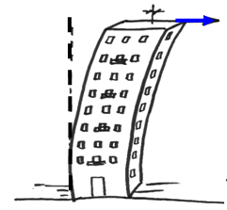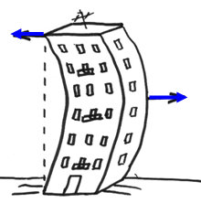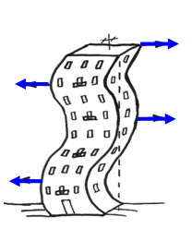

Bending fluctuations against the horizontal axis of the building

Fluctuation of the building in the 1st form
Fluctuation of the building in the 2nd form
Torsional fluctuation of the building

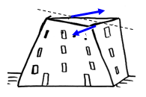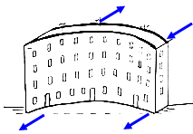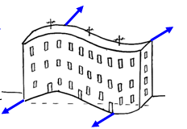

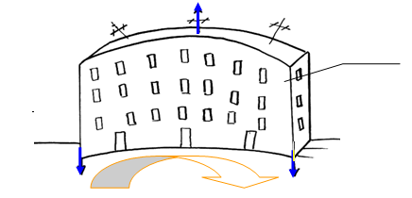

Bending fluctuation on earth foundation

Fig. 1.1. Basic forms of fluctuations of rectangular buildings

1.5. To register fluctuations, equipment with the technical characteristics given in Table 1.1 should be used.

Table 1.1
Technical characteristics of the equipment in the measuring system
No. | Name | Technical characteristics
1 | Accelerometer | Sensitivity 300 mB/m/s²;  Frequency range 1–300 Hz
2 | Accelerometer | Frequency 10 mV/m/s²;  Resonant frequency 15 Hz
3 | Amplifier | Measurement modes: acceleration, speed, displacement;  Amplification from 1 to 10,000 with stepped variation with 10 dB step;  Frequency range from 1 Hz to 20 kHz;  The number of measurement channels is at least 8;  Powered by 220 V mains or DC battery
4 | ADC | The number of channels is at least 8;  Bit depth at least 12 bits;  Ranges of measured signals: ± 5.12 V, 2.56 V, 1.024 V;  Maximum conversion frequency 300 kHz/channel
5 | PC | Must be equipped with software for input and processing of measurement information. Availability of a parallel port.
6 | Fluctuation exciter, container filled with bulk material, tamper, hammer | The weight of the container (sack) is up to 50 kg, equipped with a shock-absorbing pad;  Tamper up to 12 kg, equipped with shock-absorbing pad;  Hammer up to 2 kg, equipped with a shock-absorbing pad and a threaded hole for attaching an accelerometer;  The procedure, methodology and scope of dynamic monitoring examinations for safety important CS are established in the dynamic monitoring program

1.6. To improve the accuracy of determining frequencies and constructing epures of higher modes of fluctuations from the initial realizations recorded when applying a load at various points, the principle of superposition is used.
The use of the principle of superposition in relation to the impulse method of excitation of CS free fluctuations is:
excitation and registration of fluctuations under the action of a point impulse load applied at various points of the structure;
addition (taking into account the direction of the load) of fluctuations recorded when the load is applied at various points of the structure (imitation of the simultaneous application of the load at several points).
1.7. The processing of the fluctuations obtained as a result of addition (combined realizations) in order to isolate the resonant peaks corresponding to the analyzed form of fluctuations is carried out for each measurement point by adding or subtracting the realizations obtained from individual impacts. The inclusion of a realization in a minus sign combination means that the action in the opposite direction is modeled when the combination is composed. The realizations included in a combination and their sign are chosen in such a way as to amplify the fluctuations in the direction of the applied load.
Example 1: Creating combined realizations for a nine-story building extended in plan
Fig. 1.2 (a) shows a diagram of excitation of fluctuations.
Examples of making combined realizations for horizontal and vertical measurements according to the layout of sensors are shown in fig. 1.2(b).
У₁
У₂
У₃
Fig. 1.2 (a). Diagram of excitation of fluctuations
Points of actual load application

Рис. 1.2 (б). Схема расстановки датчиков

Fig. 1.2 (b). Layout of sensors

Figures 1.3, 1.5 and 1.7 show the records of fluctuations at the points of the horizontal alignment, recorded during impacts U1, U2 and U3; Figures 1.4, 1.6, and 1.8 show the spectra of these fluctuations.
Figures 1.9 and 1.10 show fluctuation records for the case of combined realizations for impacts (U1–U3) created to isolate torsional fluctuations and their spectra; Figures 1.11 and 1.12 show realizations for impacts (U1–U2+U3) created to highlight bending fluctuations along the front of the building and their spectra.
The resulting combined realizations are processed in the same way as any original realizations.
The epures of torsional fluctuations and bending fluctuations along the front of the building are shown in Figures 1.13 and 1.14, respectively.
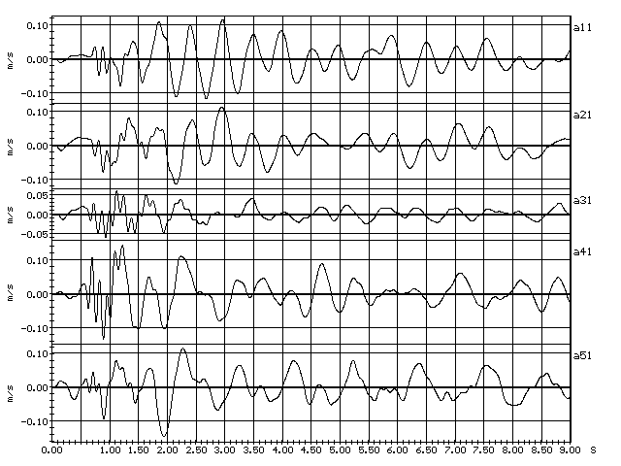
Fig. 1.3. Building fluctuations under impact U1
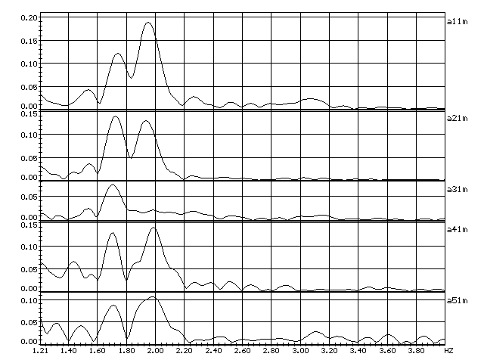
Fig. 1.4. Spectra of building fluctuations under impact U1

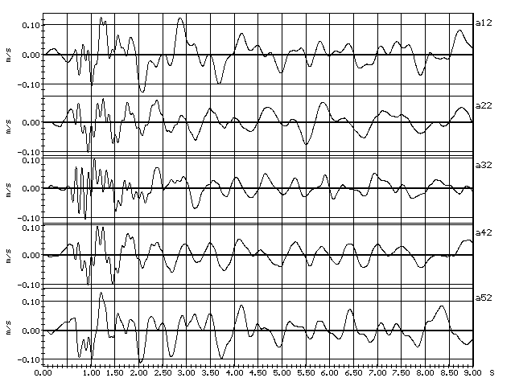
Fig. 1.5. Building fluctuations under impact U1
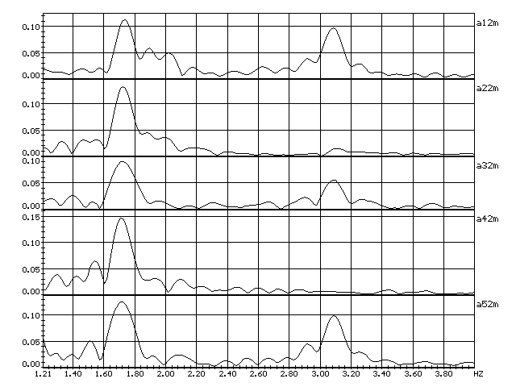
Fig. 1.6. Spectra of building fluctuations under impact U2

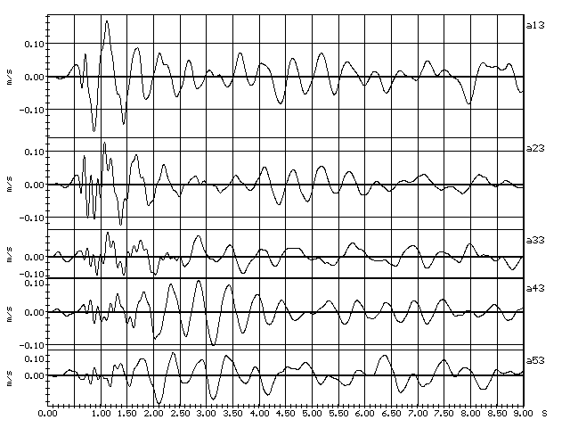
Fig. 1.7. Building fluctuations under impact U3
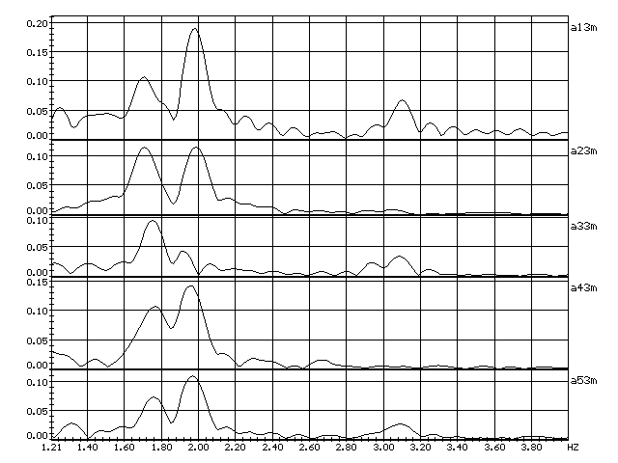
Fig. 1.8. Spectra of building fluctuations under impact U3

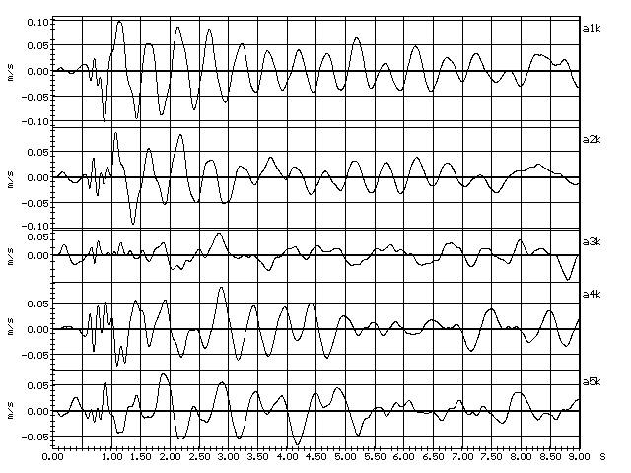
Fig. 1.9. Combined realizations
(torsional fluctuations)
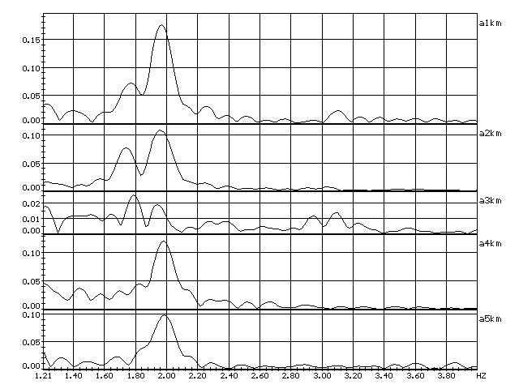
Fig. 1.10. Spectra of combined realizations
(torsional fluctuations)
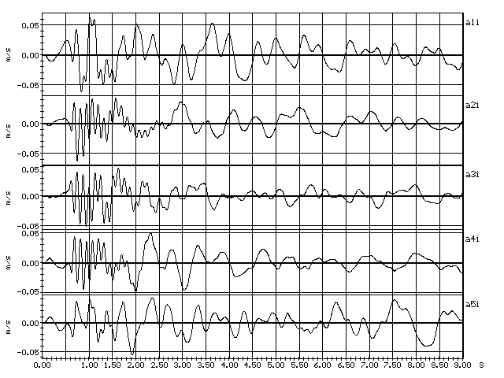
Fig. 1.11. Combined realizations
(1st frequency of bending fluctuations along the front of the building)

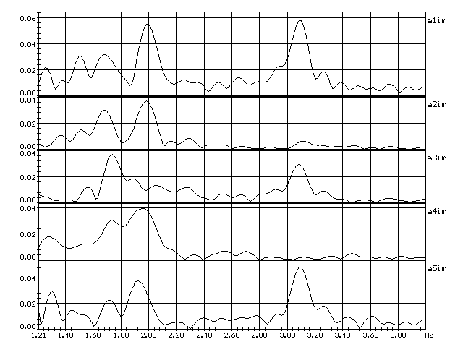
Fig. 1.12. Spectra of combined realizations
(1st frequency of bending fluctuations along the front of the building)

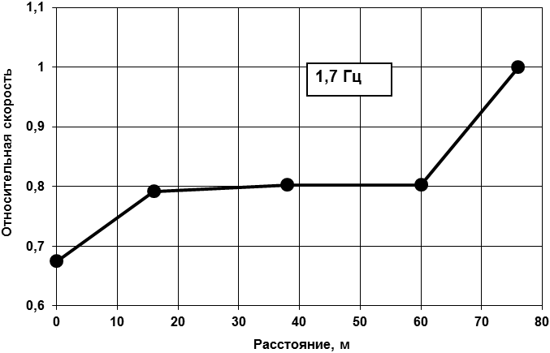
Fig. 1.13. Epure of torsional fluctuations
(horizontal alignment, transverse direction, 1st frequency)
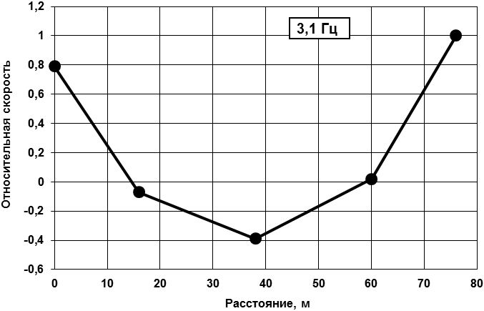
Fig. 1.14. Epure of bending fluctuations
(horizontal alignment, bending along the front, 1st frequency)

2. Evaluation of integral characteristics of materials using elastic waves
2.1. To assess the integral physical and mechanical characteristics of the material, the method with excitation of surface elastic waves in the structures should be used.
2.2. The method using elastic surface waves in the acoustic frequency range is intended to assess the state of the material of flat multilayer CS that allow the installation of measuring sensors on one of the surfaces. The length of the surface of the structure accessible for inspection should be at least three depths of its probing.
2.3. The assessment of material characteristics is carried out in three stages:
at the first stage, the response of the CS surface to the impact impulse action are determined;
at the second stage, the response of multilayer structures to the impact impulse action is theoretically modeled;
at the third stage, the results of measurement and simulation are processed, a comparative analysis of the experimental and calculated dispersion curves (dependence of the wave velocity on its length) of surface waves and the adaptation of the acoustic parameters of the model according to the criterion of coincidence of the dispersion curves by the iteration method are carried out.
2.4. The block diagram of the algorithm for monitoring the state of multilayer structures is shown in fig. 2.1.
The correlation dependences between the acoustic characteristics of the structure material (usually the longitudinal wave velocity) and its strength are used to evaluate the actual strength characteristics of the structure materials and their compliance with the design values.

Experimental determination of structure response to impulse action
Development of mathematical model of multilayered structure, entry of parameters
Output of acoustic and geometrical parameters of multilayered structure
Comparison of experimental and calculated dispersion curves and/or hodographs
Processing of results, building of dispersion curves and/or hodographs of surface wave velocity along the length of measuring alignment
Calculation of structure model response to impulse action
Determination of structure material strength by correlation dependencies
inconsistent
consistent

Fig. 2.1. Block diagram of the algorithm for monitoring the condition of multilayer structures

Stage 1 – Measurement of surface waves
2.5. The acoustic characteristics of the CS material are determined by vibrations initiated by the impulse impact load applied to the surface of the structure.
For surface waves, the speed of their propagation at different wavelengths, as well as the attenuation intensity and the presence of reflections are determined.
2.6. The determination of surface wave parameters is provided with the following accuracy parameters:
the relative confidence error in determining the intensity of the attenuation of the waves is:
− 15% - when carrying out relative calibration of measurement channels;
− 20% - without relative calibration;
the confidence probability of determining the value of the relative confidence error is 0.95.
2.7. The absolute values of the elastic characteristics of the material (modulus of elasticity or shear) or different layers of the CS (for a multilayer structure) are determined from the values of the velocities of longitudinal or transverse waves for the theoretical model, provided that the actually obtained and calculated dispersion curves of surface waves are the most consistent.
2.8. The strength of the material of the structure or its individual layers is determined by the correlation between the strength and the velocity of propagation of longitudinal waves in it.
2.9. When carrying out measurements, operations should be performed and technical means should be used, the requirements for the characteristics of which are given in Table 2.1.
A typical scheme for measuring the velocity of a surface wave in a structure is shown in Fig. 2.2.
Table 2.1
Operations and means of assessing the condition of civil structures
Name of operation | Technical means and their regulatory and technical characteristics
Preparing and taking measurements | Accelerometers, for example, types KD-20 or KV-12 manufactured by MMFR, with a sensitivity of at least 10 and 300 mV/m/s2, respectively, frequency range of 1–300 Hz, at least 5 pcs.;  accelerometers, for example, type KD-41, with a sensitivity of at least 10 mV/m/s2;  preamplifiers, for example type 2623;  connecting anti-vibration cables 5 to 80 m long;  matching amplifiers with acceleration, speed and displacement measurement modes, gain in acceleration mode up to 10 V/mV, lower frequency limit no more than 1 Hz;  multichannel ADC, for example, type E330 by L-CARD;  PC with software;  vibration excitation means, e.g. tamper, hammer

Fig. 2.2. Scheme for measuring the surface wave velocity in a structure (A1–A7 are accelerometer installation points, PU1 and PU2 are load application points)
2.10. To construct dispersion curves, separate measuring beams are selected in different parts of the surface of the structure, and for constructing velocity hodographs, measuring sections formed by several measuring beams are selected (arrangements with indices "a" and "b" in Fig. 2.2). In this case, the measuring beams are located on one straight line and are displaced relative to each other along the measuring range by a constant step.
2.11. The surface on which the accelerometer is placed is prepared for the installation of sensors, cleaned of dust, peeling paint, etc., if necessary, dried and covered with a thin layer of plasticine or special mastic.
2.12. The scheme of the measuring system (Fig. 2.3) is a serial connection of primary measuring transducers (accelerometers), matching amplifiers, a multichannel ADC and a PC. One of the measurement channels is reserved for an accelerometer mounted on an impact weight to measure the moment of application and the magnitude of the impact load impulse.
2.13. When choosing measurement points and the type of sensors, one should take into account the nature of the source of fluctuations, the intensity and duration of fluctuations, the duration of measurements, the measurement error, including due to interference of natural and man-made origin. Simultaneous three-component recording of fluctuations at each measurement point is recommended.
2.14. To excite fluctuations, a tamper (hammer) is prepared, on which a piezoaccelerometer is fixed. The duration of the impact impulse is regulated by shock-absorbing pads fixed on the tamper.
2.15. The tamper is a wooden beam weighing 10 to 12 kg, one of the ends of which is hemispherical or equipped with a spherical tip made of an elastic material. The accelerometer for measuring the load is mounted on the other end of the tamper. To excite low-frequency waves, a heavier tamper with a soft tip (foam rubber, porous rubber) should be used.
Fig. 2.3. Diagram of measuring system
(А1–Аn, Ау – piezoelectric accelerometers, AVK1–AVKn – anti-vibration cables, U1–Un – matching amplifiers, PU – preamplifier)
Stage 2 – Mathematical modeling
2.16. For cases where the structure under examination can be considered as a homogeneous half-space or a homogeneous slab, the acoustic characteristics of the structure material are determined as follows:
for a half-space, the speed of a surface wave is equal to the speed of a Rayleigh wave;
the dispersion curve of surface (bending) waves in a slab with a given velocity of the Rayleigh wave in its material V_{R} and the slab thickness is constructed by solving an analytical equation as follows:
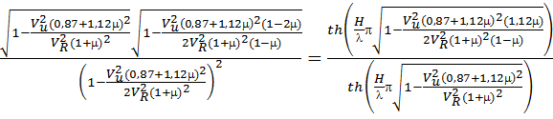, (1)
where
H is thickness of the slab;
λ is length of the bending wave;
μ is Poisson’s ratio;
V_{и} is phase velocity of the bending wave.
2.17. Mathematical modeling of the response of a multilayer structure to impact impulse action is based on the integration of the governing system of equations by a numerical method in a flat formulation.
Stage 3 – Processing test results
2.18. Test results should be processed with a PC. The initial realizations of wave processes are separated in the PC into monochromatic beams using a group of band pass filters. For selected beams of monochromatic waves, the propagation time of the wave is determined sequentially for all measurement points. Time is determined by the maxima of the wave or by the intersection of the fluctuation with the zero line.
For each reading of the propagation time of a monochromatic wave beam, the phase velocity of wave propagation is determined:
V = L/t , (2)
where
L is the length of the segment on which the speed between measurement points is determined, m;
t is travel time on this segment by a surface wave, s.
The wavelength is:
λ = Τ · V , (3)
where T is the fluctuation period in a monochromatic wave beam, sec.
2.19. To construct dispersion curves in a measuring beam section with a length of at least four accelerometer spacing steps, each monochromatic wave beam is processed to obtain several counts of the wave travel time from the beginning to the end of the section. Then, for each case, the speed and wavelength are calculated. The data set thus obtained "velocity - wavelength" is filtered to obtain a smooth dispersion curve.
The velocity section along the length of the measuring section is determined by the average travel time of the distance between each pair of measurement points in the measuring beam for all spacings in both directions of wave propagation, which makes it possible to calculate the wave speed and its length. The entire range of the obtained wavelengths is divided into 2 or 3 sections, where the average wave speed is calculated and graphs of the change in the wave speed along the length of the section are plotted.
Example 2. Creating selected beam of monochromatic wave
Fig. 2.4 shows an example of the original realization and a selected beam of a monochromatic wave with superimposed lines of hodographs of the wave travel times.

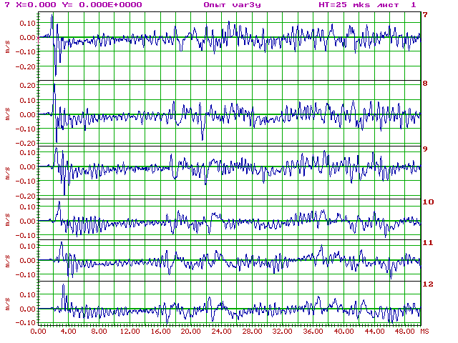
a)
b)
Fig. 2.4. Example of original realization (a) and selected beam of monochromatic wave (b)

2.20. The results of processing the wave processes of the structure’s response to impact impulse action are used to determine the acoustic characteristics of CS materials by comparing the dispersion curves of the surface waves obtained from experimental and calculated theoretical responses to impact impulse action.
2.21. The parameters (geometric and acoustic) of the multilayer CS model are selected by iterations and with regard for the results of examination by other methods until the best agreement between the theoretical and experimental dispersion curves is achieved.
2.22. The elastic characteristics of the CS materials are determined by the acoustic characteristics of various CS layers obtained in the mathematical model as a result of its adaptation, taking into account information about the properties of the material of the structure (density, Poisson’s ratio, etc.) according to the formulas:
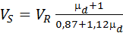; (4)
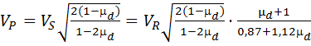; (5)
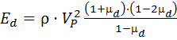; (6)
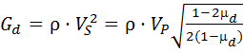, (7)

where
V_{S}, V_{R}, V_{P} are velocities of transverse, Rayleigh and longitudinal waves, respectively, m/s;
E_{d} is concrete elasticity modulus, Pa;
G_{d} is concrete shear modulus, Pa;
ρ is concrete density, kg/m³;
µ_{d} is dynamic Poisson’s ratio.
2.23. The strength of the structure material is determined by the correlation dependences between the strength of the material and the velocity of propagation of a longitudinal elastic wave in it.
2.24. According to the results of tests using surface waves, the following data should be provided:
hodographs of surface wave velocities of various types;
dispersion curves of waves on the most typical measuring beams;
basic acoustic characteristics of the structure material;
velocities of longitudinal and transverse waves in various parts of the surface of the structure;
their respective elasticity and shear moduli of the material;
the strength of the structure material in various parts of its surface.
2.25. To determine the strength of concrete, the calibration curve shown in fig. 2.5 should be used, and to determine the strength of brickwork, the data in table No. 2.1 should be used.
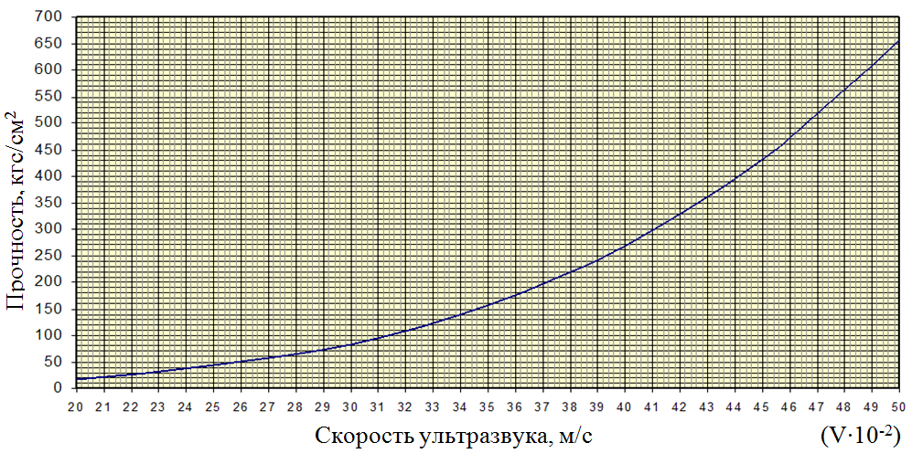
(V10⁻²)
Fig. 2.5. Calibration curve for assessing the strength of concrete
Table 2.1
Qualitative classification of brickwork strength according to velocities of seismoacoustic range
Description of brickwork | Characteristic compressive strength of brickwork  (R_{n}, MPa) | Longitudinal wave velocity of seismoacoustic frequency range  (V_{p} , m/s)
Very strong | 4–4,5 | > 3 000
Strong | 3–4 | 2 000–3 000
Reduced strength | 2–3 | 1 500–2 000
Low strength | 1.5–2 | 1 000–1 500
Weak strength | 1–1.5 | 500–1 000
Very weak strength | 0.5–1 | ∼ 500

3. Identification of defective zones in material of civil structures by through scanning
3.1. To identify defective zones in the CS material, through scanning should be used, which is based on measuring the propagation velocity of acoustic waves, longitudinal or transverse ones, in the material. Determining the values of these velocities at various points of the structure makes it possible to identify defective zones and evaluate the elastic characteristics of the structure.
3.2. To build the field of wave propagation velocities in a civil structure, programs for tomographic processing of the results of measuring the travel times of a wave between its sources and receivers are used.
3.3. To construct a velocity section of a structure, a database is determined, which is a group of tables containing the coordinates of wave sources and receivers, and the wave travel times between them.
3.4. The excitation and registration of longitudinal or transverse elastic waves can be carried out with any means that allow fixing the wave travel time with acceptable accuracy:
the source must provide a short wave front (up to 1 m/sec);
receivers (sensors) must be wideband (1–3000 Hz) in order to measure this wave without dynamic distortion.
3.5. The algorithm for calculating the velocity section of a structure should be organized as follows:
tables of wave travel times between all sources and receivers are introduced;
the initial model of the structure is introduced in the form of a layered medium: the relative thicknesses of the layers, the relative velocities at the boundaries of the layers and the angle of inclination of the plane of the layers to the coordinate axes, while the velocity along the left boundary of the first layer V₀ is taken equal to unity;
the travel times of the waves are calculated along all given beams for a given design model at wave velocities equal to given relative velocities;
the velocity V₀ is calculated as the ratio of the sums of the wave travel times along all the beams;
the root-mean-square deviation of the experimental and calculated wave travel times is calculated;
the method of iterations determines the velocity section of the structure, at which the root-mean-square deviation of the experimental and calculated wave travel times reaches a minimum value;
for the “optimal velocity section,” the absolute values of the velocities at the boundaries of the layers are calculated, and a graph is plotted in the coordinates “distance (along the axis perpendicular to the plane of the layers) – wave propagation velocity”;
beam trajectories are calculated, and a situational plan is constructed, on which the beam trajectories and isolines of wave propagation velocities are plotted.
Example 3. Calculating beam trajectories
To calculate the beam trajectories, the system of equations should be used as follows:
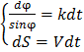, (8)
where
k is the wave velocity gradient;
ϕ is the angle between the wave velocity gradient vector and the direction of wave propagation along the beam;
V wave propagation velocity;
S is the wave path along the beam;
t is wave travel time.
For a gradient layer, in which the wave velocity gradient is constant in magnitude and direction and is directed along the x axis, the system of equations (8) takes the form as follows:
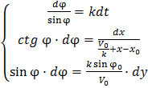, (9)
where ϕ₀, V₀, x₀, y₀ are the values of the corresponding quantities at the starting point of the beam trajectory in the given layer.
In this case, the gradient is defined as the derivative of the wave propagation velocity along the x axis:
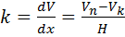, (10)
where
V_{n}, V_{k} are wave propagation velocities at the beginning and at the end of the layer, respectively (along the direction of the x axis);
H is width of the layer.
After integration, the system of equations (9) takes the form as follows:
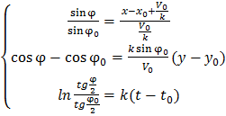, (11)
By means of the system of equations (11) for the given parameters of the velocity section, the initial values of the parameters of the beams x₀, y₀, ϕ₀, time t₀ and the final abscissa of the beam x_{k} corresponding to the layer boundary or the abscissa of the wave receiver, it is possible to calculate all the parameters of the ray at the end point (y_{k} , ϕ₀) and the wave travel time from x₀ to x_{k}(t₀).
In this case, it should be taken into account that if, in any layer ϕ₀ < 90°, then the trajectory can have two branches (direct and reverse), if x_{k} of the layer is greater than
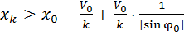, (12)
in this case, the trajectory returns to the beginning of the layer.
The beam is calculated using the system of equations (11) by the iteration method. First, the angle of the exit of the beam ϕ₀ from the wave source is set (it is also possible to count from the receiver to the source, if in this case the calculation is simplified), and the beam trajectory is built up to x₀ of the receiver abscissa sequentially for each layer. In this case, in each next layer, the initial parameters of the beam are taken equal to the final parameters of the beam in the previous layer. Having completed the beam to the axis x₀, the ordinate of the beam y_{k} is compared with the receiver ordinate y₀. Then, ϕ₀ is changed by the value of the initial step Δϕ₀ in such a way as to reduce the difference (y_{k} – y), and the ray trajectory is calculated again. After changing the sign of the difference of y_{k} and y₀, the amount of step change for ϕ₀ is reduced, a step in the opposite direction is taken, and so on until the following condition is met:
, (13)
The wave travel time along the trajectory calculated in this way for each beam is entered in the table.
_________________

APPENDIX 5
to Safety Guide in the use of atomic energy “Dynamic Monitoring of Civil Structures of Nuclear Facilities” approved by Order of Federal Environmental, Industrial and Nuclear Supervision Service No. 84 of March 22, 2022
Assessing resistance of civil structures of buildings and constructions under external effects
1. Analysis methods

1.1. Response spectrum method
The response spectrum method involves the use of an external effect in the form of a spectral curve (response spectrum) of the dependence of acceleration on natural frequencies ω. The specified response spectrum depends on the elevation of the equipment and on the value of the relative damping.
The response spectrum is obtained on the basis of the response of the simplest dynamic system (linear non-conservative oscillator) to a seismic disturbance. After calculating the oscillations of oscillators with different values of its dynamic parameters (natural frequency f and energy dissipation factor k), the dependence of the maximum values of absolute accelerations on their natural frequencies and factors k is constructed, which is called the acceleration spectrum or the response spectrum.
It should be noted that the response spectrum can be calculated by superposition and probabilistic processing of the spectra obtained from many accelerograms. Then it will reflect the experience of various external effects.
The damping parameters of fluctuations (logarithmic decrements of fluctuations) should be taken on the basis of special justifications. In the absence of experimental data, the values of the logarithmic decrements of fluctuations can be taken according to Table 1.

Table 1
Values of logarithmic decrements for civil structures of buildings and constructions
Type of structure | Logarithmic fluctuation decrement δ in fractions of critical value at design stress values  depending on design material resistance of structure R
Type of structure | ⬧ = 0.67R | ⬧ ≥ 0.9R
Regular reinforced concrete structures | 0.04 | 0.07
Prestressed reinforced concrete structures | 0.02 | 0.05
Welded steel structures | 0.02 | 0.04
Bolted steel structures | 0.04 | 0.07
Large diameter equipment and piping systems (> 300 mm) | 0.02 | 0.03
Small diameter equipment and piping systems ( 300 mm) | 0.01 | 0.02
The response spectrum method is based on the method of expansion of the motion of the system in terms of the forms of its natural fluctuations.
To assess the seismic resistance of the CS, the first seven or eight fluctuation modes in the low-frequency area (up to 33 Hz) are usually taken into account due to the low-frequency nature of seismic fluctuations.
To assess the stability of the CS under high-frequency external influences (aircraft crash, air shock wave, etc.), it is necessary to take into account many more fluctuation modes (up to 30), which is due to the possible presence of a large number of CS natural frequencies in the high-frequency area (33–400 Hz).
Based on a number of assumptions, the response spectrum method simplifies the solution of the problem of forced external effect and makes it possible to estimate the stress-strain state of the structure with an error, which, as a rule, tends to increase the safety factor. The main disadvantage of the method is the impossibility of calculating nonlinear systems.
1.2. Dynamic analysis method
The dynamic analysis method provides for the use of the accelerogram of the movement of the base of the calculation model as an external effect. The solution of the problem is done by methods of numerical integration of systems of differential equations of motion. In this case, the design model of the structure can be non-linear. Modern achievements in the field of computer technology and existing software systems make it possible to effectively use the dynamic analysis method to assess the resistance to external effects of power equipment of any complexity.
2. General principles for constructing calculation models
2.1. The calculation model of the B&C in the analysis of their stability under external effects is a dynamic system with concentrated and/or distributed masses, which quite fully reflects the main dynamic properties of the object under consideration, the reactions of which can be used to evaluate the resistance under external effects of an actual structure. The model must provide the required accuracy in assessing the dynamic response of the structure, satisfy the scope of the necessary design verification, the capabilities of computer calculation programs, and the chosen calculation methods.
The capabilities of modern computing systems and computers make it possible to consider complex combined calculation models, including spatial and planar rod systems, shell elements, absolutely rigid bodies, and nonlinear elements. The complexity of the chosen model depends on the type of structure, calculation method, and criteria of resistance to external effects.
2.2. The construction of the calculation model and its calculation are carried out in the following order:
preliminary division of the system into constituent elements;
assignment of nodal points and generalized coordinates;
determination of inertial and elastic characteristics;
calculation of dynamic characteristics;
selection of calculation methods for seismic resistance, depending on the values of the frequencies of natural vibrations of the calculation model, the category of seismic resistance and the seismicity of the site;
selection of calculation methods for stability under other external effects, depending on the values of the frequencies of natural fluctuations of the calculation model and the nature of the external effects;
appointment of criteria for assessing resistance to external effects;
refinement of the calculation model, if necessary, the construction of several models corresponding to the selected evaluation criteria;
refined calculation of dynamic characteristics (if required by the selected calculation method);
calculation of system characteristics assigned as evaluation criteria from the required type of effect, given in the form of an accelerogram, a response spectrum, a concentrated or distributed external load.
2.3. The initial data for the construction of calculation models are working and installation drawings, structural diagrams of equipment, datasheet and other data that can be supplemented based on the results of visual inspection and geometric measurements in actual installation and piping conditions.
2.4. The compliance of calculated values of intrinsic dynamic characteristics with real values and subsequent correction of design schemes should be done. After obtaining the values of natural fluctuation frequencies of the B&C by the calculation method, the calculation model is corrected by a small change in the parameters on which the rigidity of the structure depends, according to the following principles:
increments should be as small as possible; the direction of movement of the scheme elements along the lower vibration modes should not change;
the parameters of the cross sections of the bar and shell elements should not be changed if the maximum stress values are expected in them;
as a result of refinement, the calculated values of the lowest natural frequencies should approach the values obtained experimentally.
3. Structural schemes of buildings and constructions
A frame system with a space frame is most commonly used in the construction of public and industrial buildings. The main elements of the frame are columns, crossbars, floor slabs and ties. Depending on the materials from which the racks and crossbars are made, frames are divided into reinforced concrete, metal and combined.
A reinforced concrete frame is the main type of frame assembled from unified elements of mass factory or polygon production. Coupling of posts, as well as other elements of a precast concrete frame, are carried out by welding protruding bars followed by their embedding with concrete.
Metal frames (steel and aluminum alloys) are made from various rolled profiles (sheets, angles, channels, I-beams, pipes, etc.).
The most widespread are the following combined frames, in which vertical supporting structures are assembled from various elements, rod and planar ones.
The incomplete frame scheme is based on a combination of load-bearing walls and a frame that perceives all vertical and horizontal loads. The system is used in two versions: with load-bearing outer walls and an inner frame, or with a frame and inner walls.
In the frame-diaphragm scheme, all or most of the horizontal loads and effects are transferred to the wall elements (vertical stiffeners - diaphragms), and mainly vertical loads are transferred to the rod (supporting frame).
The frame-block scheme is based on a combination of a frame and three-dimensional blocks, and three-dimensional blocks can be used in the system as (non-)load-bearing structures. Non-load-bearing volumetric blocks are used for floor-by-floor filling of the carrier grid of the frame, and the carriers are installed on top of each other.
In a frameless structural scheme with load-bearing walls, the stability of buildings, including those under seismic effects, is ensured by rigid junctions of external and internal walls, as well as their connection with ceilings. In this structural scheme, the walls are vertical, and the ceilings are horizontal rigidity diaphragms, forming a single spatial system.
The walls of buildings with a frameless structural scheme are erected from large, mainly concrete, blocks (large-block buildings) and large concrete or reinforced concrete panels with effective insulation (large-panel buildings). The frameless structural scheme includes buildings made of monolithic reinforced concrete.
Buildings with different structural schemes should be modeled using one of the following three-dimensional or flat design schemes: rod, plate, volumetric or combined.
The selection of the calculation scheme is determined by the type of load-bearing elements and the load perception scheme of the CS of the building, taking into account the criteria for the limit conditions defined in the relevant regulatory documents for reinforced concrete, stone, metal and wooden structures.
When developing calculation models of existing buildings, the defects identified during dynamic tests for individual elements, assemblies or fragments of the CS should be taken into account. This procedure should be performed in accordance with the recommendations of regulatory documents by introducing the factor of reduction in bearing capacity.
When developing a calculation model of a building, taking into account the results of the survey, the actual structural system of the building that exists at the time of the survey should be established. In the calculation model of the building, the actual performance of the support nodes and interfaces of structural elements, the presence and state of connections that ensure the spatial rigidity of the building and its elements should be reflected. In addition, the actual combination of permanent and temporary loads determined during the survey should be taken into account. In particular, in reinforced concrete structures, the presence of plastic hinges in the nodal connections of continuous crossbars with columns is possible, which leads to a change in the operating conditions of these elements in the spatial scheme of the building.
When performing a design assessment of seismic resistance for the same building, design models with an increasing degree of complexity and detail should be consistently used. Consistent refinement of the calculation model makes it possible to reveal the influence of various features on the behavior of the building under seismic effects, taking into account the occurrence of damage in it. An obligatory condition for the performance of the calculation estimate is to take into account the change in the conditions of the model during the impact of an earthquake when the limit states are reached in individual elements or in the entire building.
For masonry buildings, it is recommended to take into account the following possible changes in the condition of the model:
1) The division of the building into large blocks, which is characterized by the occurrence of through cracks, penetrating, as a rule, the entire building in the vertical or horizontal directions (separation of adjacent walls from each other, separation and movement of the building along the foundation, displacement of floor discs and division of the building into blocks within floors, etc.). In this case, a dynamic calculation of the building should be performed at the fits stage using a spatial finite element model without taking damage into account. Then structural elements are determined where internal forces (stresses or deformations) exceed the limit values. Elements that operate only up to a certain level of load are introduced into the calculation model, after which they are excluded, and a repeated dynamic calculation is performed. With the formation of new area of possible destruction, the model is further refined.
2) Change in the scheme of perception of loads by the load-bearing structures of the building due to destruction (significant loss of bearing capacity by individual structural elements) or changes in the conditions for coupling the elements (the formation of horizontal cracks in the upper and/or lower parts of the walls, the formation of diagonal cracks in blank walls within the floor, etc.).
When implementing such a mechanism of destruction of the building in its calculated model, the conditions for connecting elements (the formation of a one-way bond, sliding with friction, etc.) should be changed, or the masonry deformation modulus should be locally changed, or the elements corresponding to the destroyed parts of the structure should be excluded from the calculated model. After excluding some of the elements from the calculated model, calculate the changed state of the building under static loads should be calculated and the criteria for the limit conditions should be clarified.
3) A change in the solidity of the masonry, which, as a rule, causes a decrease in the natural fluctuation frequencies of buildings, that is, rigidity. The appearance of these changes is associated with numerous internal processes occurring in the masonry under dynamic loading, and is due to the formation of microcracks and the violation of its continuity. In this case, it is recommended that the masonry deformation modulus be multiplied by the degradation factor, which depends on the realized stress-strain state in the CS of the building.
_________________

APPENDIX 6
to Safety Guide in the use of atomic energy “Dynamic Monitoring of Civil Structures of Nuclear Facilities” approved by Order of Federal Environmental, Industrial and Nuclear Supervision Service No. 84 of March 22, 2022

Recommendations for development of calculation model based on results of vibration diagnostics of civil structures of buildings and constructions
Example 1. Determination of dynamic characteristics of building
Below is a measurement scheme for determining the dynamic characteristics of a building, fig. 1 (vertical section), fig. 2 (plan).
The excitation of fluctuations is produced by the blow of a sandbag against the wall of the building in its upper part (where a large amplitude of various fluctuation modes is observed), at points U1, U2. For a better selection of higher forms of fluctuations, impacts can be applied at points U1’, U2’, and for a better selection of higher forms of fluctuations (2nd and 3rd frequencies), combined implementations of a combination of impact actions are created: U1–U1’, U2–U2’.
Figures 3–5 show the building response to impact at point U2 and their Fourier spectra, and Figures 6–7 show cross-spectra of the building response to microseismic impact.
The epures of frequencies 1 to 3 of horizontal fluctuations of the building are shown in fig. 8. In this part, the epures of bending fluctuations should be compared with the rated permissible ones.
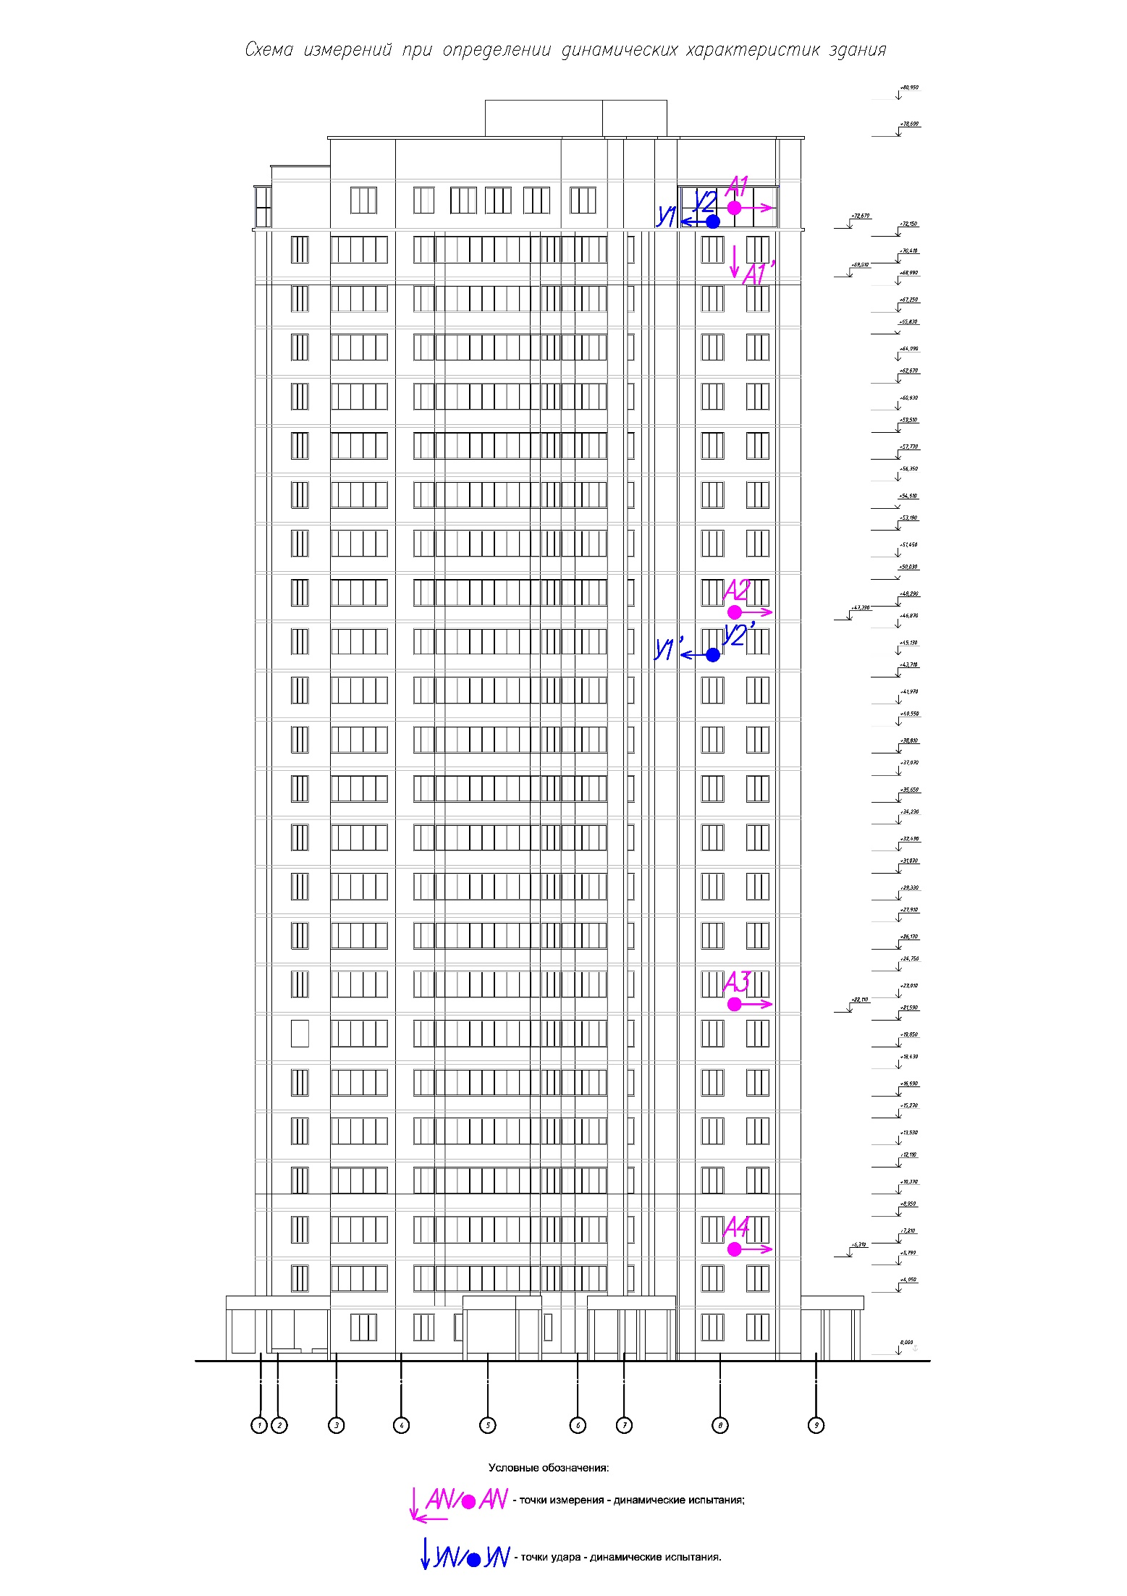
− measurement points (dynamic test)

− точки удара (динамические испытания)
Conditional обозначения:
Fig. 1. Scheme of measurements in determining dynamic characteristics of building (vertical alignment)
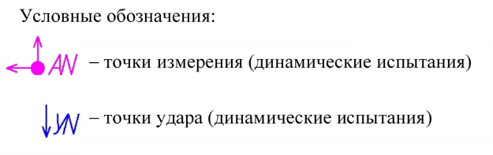
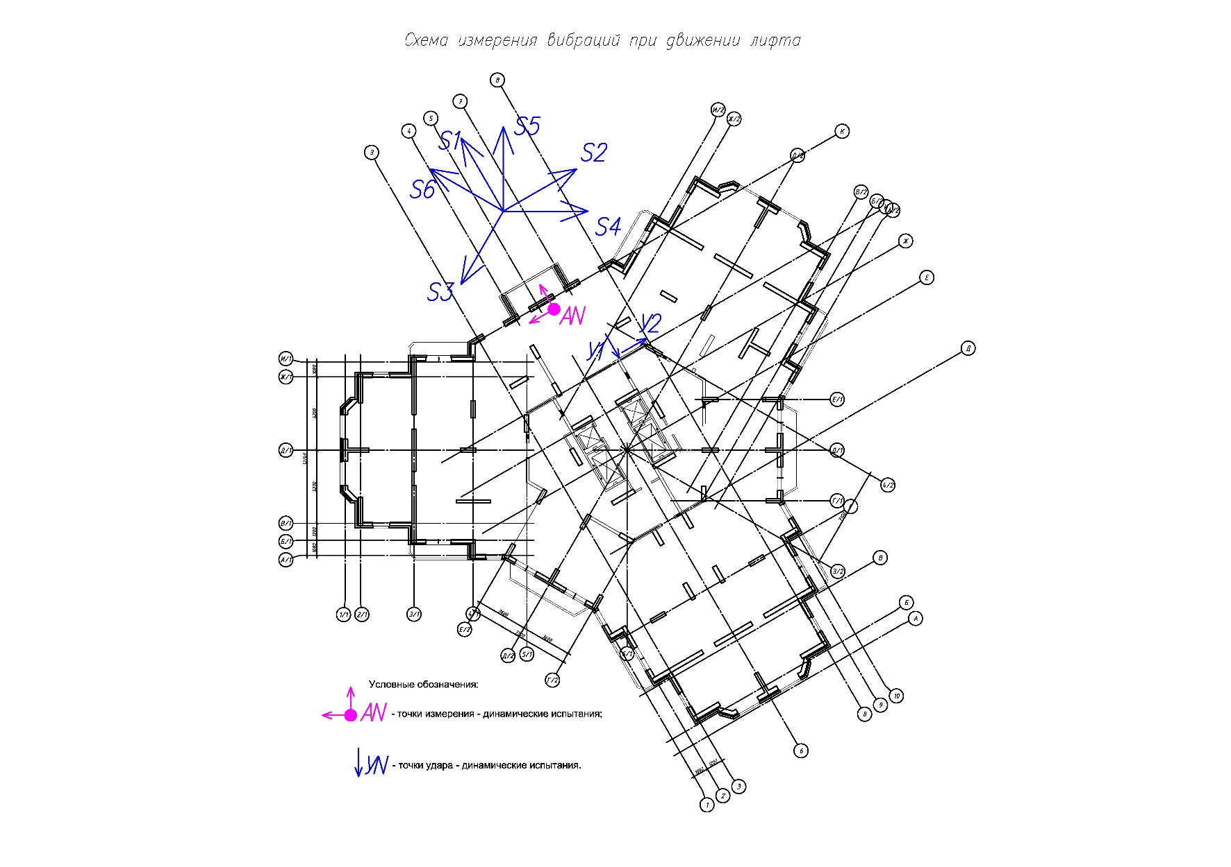
Fig. 2. Scheme of measurements in determining dynamic characteristics of building (plan)
Fig. 3. Example of building response to impact, horizontal fluctuations along direction s1

Fig. 4. Modules of Fourier spectra of building response to impact action (1st, 2nd and 3rd fluctuation frequencies are highlighted)
Fig. 5. Phases of Fourier spectra of building response to impact action (1st, 2nd and 3rd fluctuation frequencies are highlighted)

Fig. 5. Phases of Fourier spectra of building response to impact action (1st, 2nd and 3rd fluctuation frequencies are highlighted)
Fig. 7. Phases of cross-spectra of building response to microseismic impacts, fluctuations along direction s1 (1st, 2nd and 3rd fluctuation frequencies are highlighted)
Fig. 8. Epures of bending fluctuations
The determination of the dynamic characteristics of individual elements of a building or construction is carried out using the same measuring instruments and software. In this case, more rigid means of excitation of fluctuations can be used, for example, a wooden beam with a shock-absorbing tip.
In the case when the number of sensors in the measuring system is less than the required number of measurement points, tests are carried out with several sensor layouts. At the same time, to compare the results in each next measurement scheme, one or two points from the previous one are provided (Example 2).
Example 2: Determination of floor dynamic characteristics
Figure 9 shows an example of measurement schemes for determining the dynamic characteristics of a floor in a building. To ensure the construction of fluctuation epures along the entire length of the floor, tests are carried out according to several sensor layout schemes, while at each point of the next scheme, two points from the previous one are provided.
Combined realizations for the required combination of impact actions are created to highlight various forms of floor fluctuations. The combination (U1+U2+U3+U4+U5+U6) was created to isolate the 1st fluctuation frequency, and (U1–U2+U3–U4+U5–U6) to isolate the 2nd.
The resulting combined realizations and their Fourier spectra are shown in figs. 10 to 15, the epures of the 1st and 2nd fluctuation frequencies are shown in fig. 16.

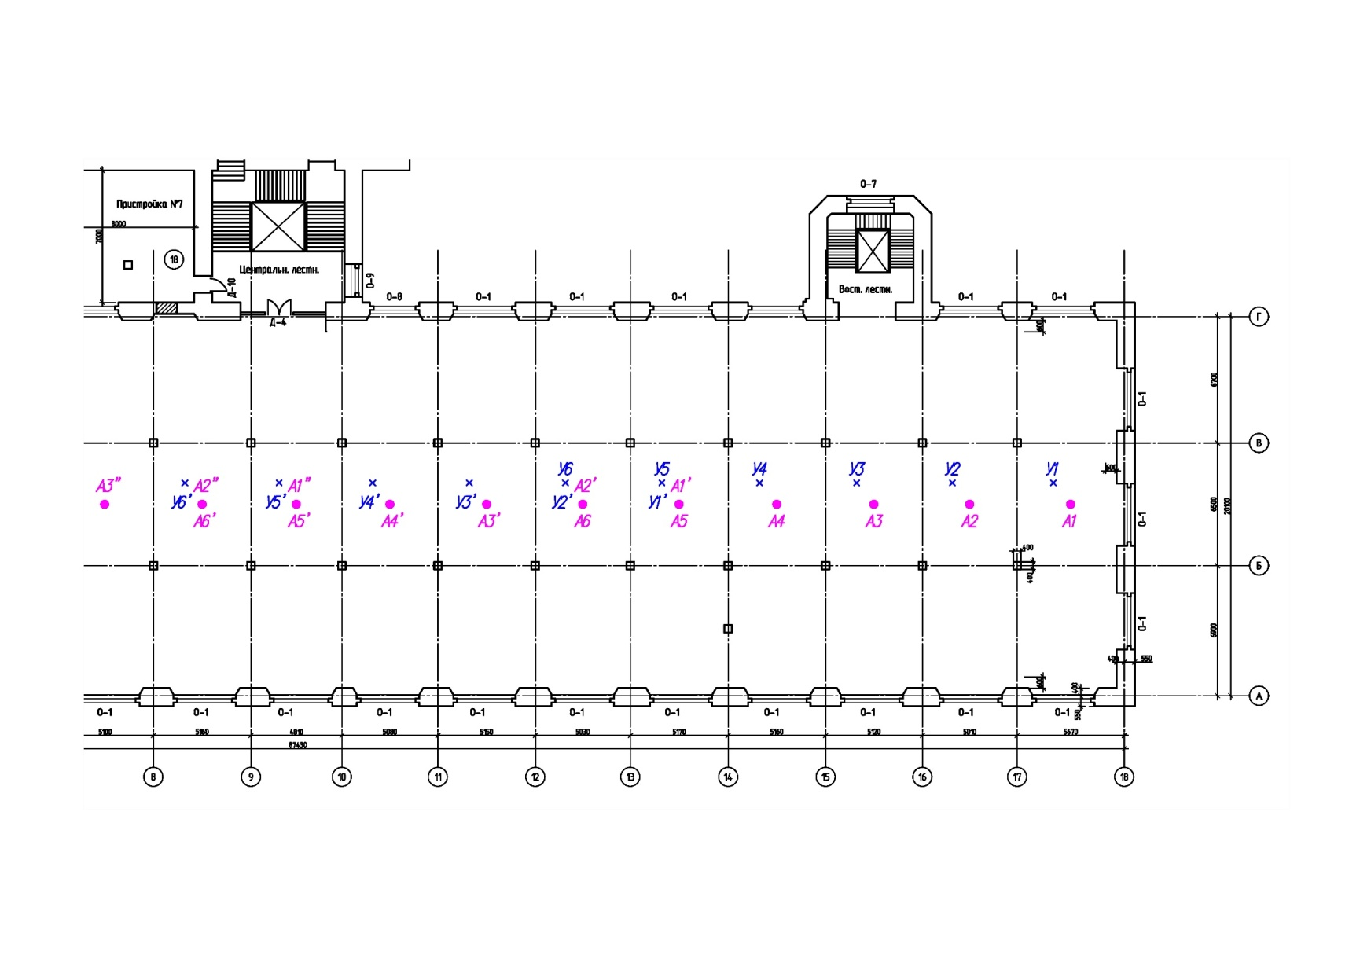

Fig. 9. Schemes for measuring floor dynamic characteristics

Fig. 10. Example of examined floor response to combination of impacts
U1+U2+U3+U4+U5+U6 to identify 1st fluctuation frequency

Fig. 11. Modules of Fourier spectra of examined floor response to combination of impact actions, 1st fluctuation frequency is highlighted

Fig. 12. Phases of Fourier spectra of examined floor response to combination of impact actions, 1st fluctuation frequency is highlighted

Fig. 13. Example of floor response to combination of impacts U1–U2+U3–U4+U5–U6 to highlight 2nd fluctuation frequency

Fig. 14. Modules of Fourier spectra of floor responses to combination of impact actions (2nd fluctuation frequency is highlighted)

Fig. 15. Phases of Fourier spectra of floor responses to combination of impact actions (2nd fluctuation frequency is highlighted)

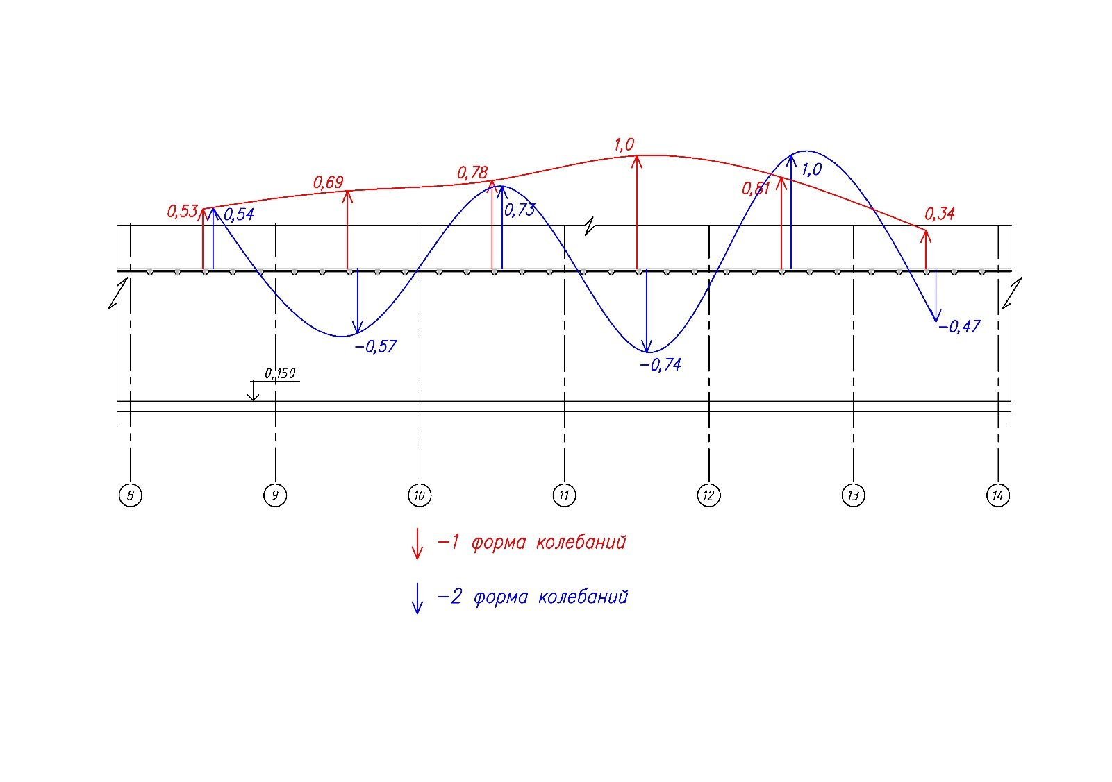
Fig. 16. Epures of floor fluctuations

Table 1 shows an example of a table with results of calculated fluctuation periods of the calculation model developed and refined on the basis of vibrodynamic tests and actual physical and mechanical characteristics of CS materials.
Table 1
Example of table with calculation results
Loadcase | Frequency No. | Eigen value | Frequency |  | Period | Modal masses (%) |  |  | Modal contribution coefficients
Loadcase | Frequency No. | Eigen value | rad/s | Hz | s | Х | Y | Z | Х |  | Y |  | Z
 |  |  |  |  |  |  |  |  | (kg)^{0.5}
Modal analysis | 1 | 0.203 | 4.916 | 0.782 | 1.278 | 0 | 71.842 | 0 | 35.310 | 37.821 |  | 48.386
Modal analysis | 2 | 0.191 | 5.224 | 0.831 | 1.203 | 70.394 | 0 | 0 | 37.438 | 10.788 |  | 77.350
Modal analysis | 3 | 0.166 | 6.039 | 0.961 | 1.040 | 0.143 | 0.106 | 0 | 44.344 | 33.510 |  | 62.570

____________________

